Chunk default batch size is 200

**Default chunk size (batch size)** in a **Batch Apex** job is **200 records per batch**.

Start method calling execute method multiple times

Always start method will executes only one time

Execute method will executes how many times

Total number of records/batch size (200 by default)

Here we can follow asynchronous

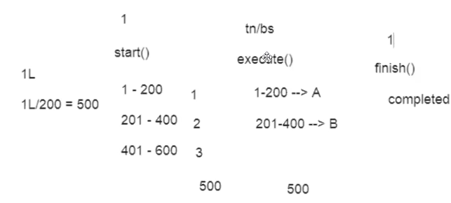

In **Apex**, the methods start(), execute(), and finish() are called as:

**🔹 Batch Apex Lifecycle Methods**

These three methods define the structure of a **Batch Apex class**, which is used to process large amounts of data asynchronously.

**✅ Details:**

| **Method** | **Purpose** |
| --- | --- |
| start() | Called at the beginning. It returns the scope of records to process. |
| execute() | Called for each batch of data. Contains the logic to process records. |
| finish() | Called at the end. Used for post-processing like sending emails, etc. |

**🔸 In short:**

**start(), execute(), finish() → are called Batch Apex Lifecycle Methods in Salesforce Apex.**

Through batch apex we are handling the bulk records

Start(), execute() and finish() are abstract methods

Need to increase the amount by 30%

To use batch apex, need to deactivate the triggers why because if we have 1lakhs records the triggers also getting executed

**Apex Batch Jobs in Salesforce**

In **Apex**, a **Batch Job** is a way to process **large volumes of records asynchronously** — in manageable chunks — without hitting governor limits.

**✅ When to Use Batch Apex?**

Use **Batch Apex** when:

* You need to **process >50,000 records**
* You’re performing **long-running operations**
* You want **asynchronous execution** with controlled batch sizes

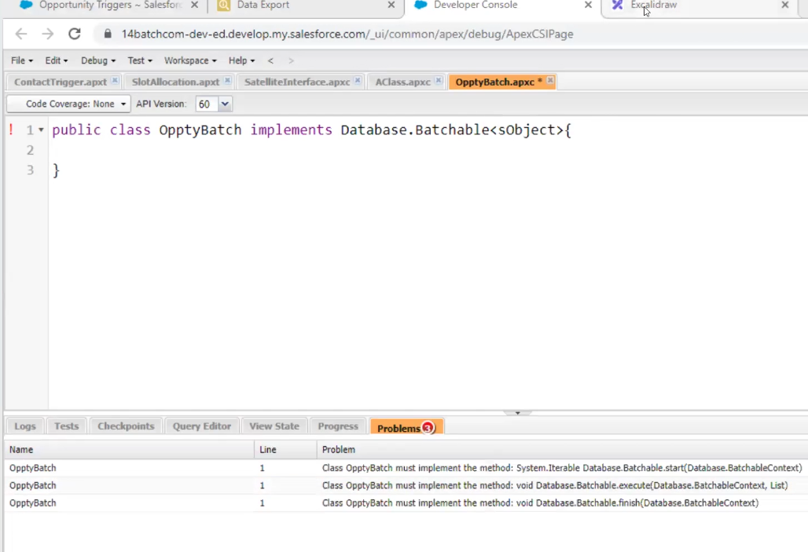

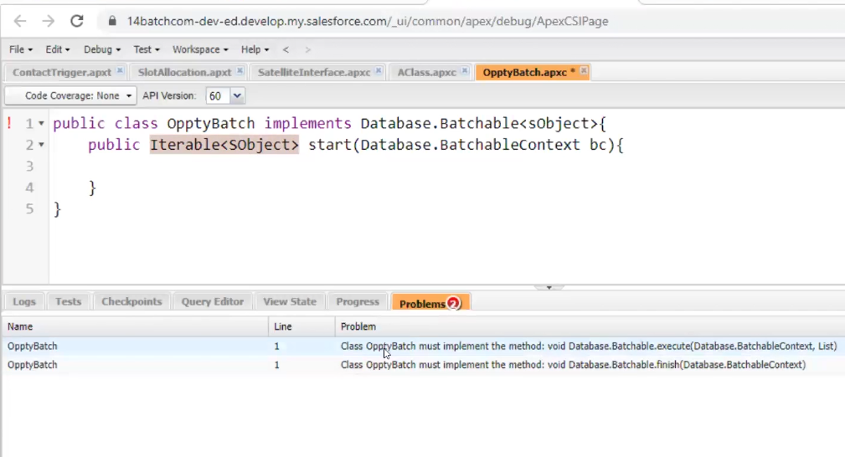

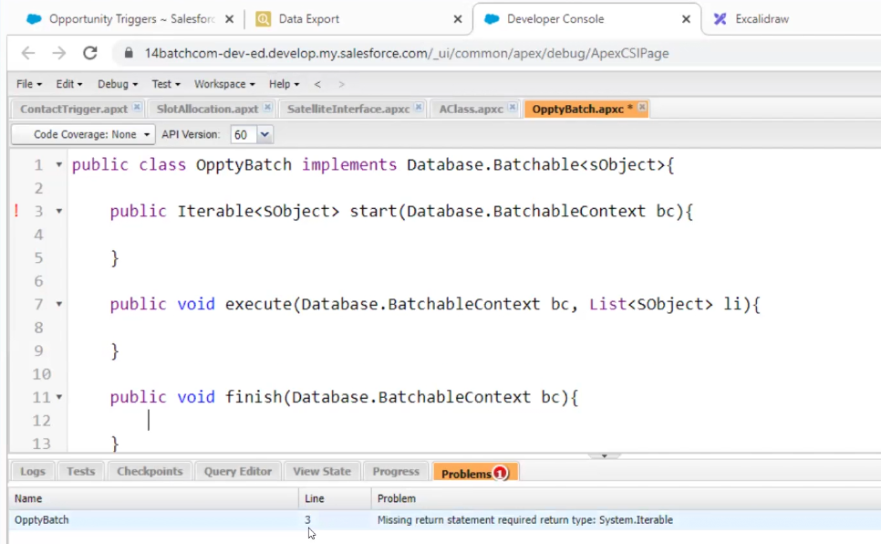

The batch apex is asynchronous

Here data is not updated why see in next class why because of null pointer exception

